**DAILY ONLINE ACTIVITIES SUMMARY**

|  |  |  |  |  |  |  |  |  |
| --- | --- | --- | --- | --- | --- | --- | --- | --- |
| **Date:** | **06-06-2020** | | | | | **Name:** | **Huda Sultana** | |
| **Sem & Sec** | **8 A** | | | | | **USN:** | **4AL16CS039** | |
| **Online Test Summary** | | | | | | | | |
| **Subject** | | **-** | | | | | | |
| **Max. Marks** | | **-** | | **Score** | | | **-** | |
| **Certification Course Summary** | | | | | | | | |
| **Course** | **Introduction to AWS Fargate** | | | | | | | |
| **Certificate Provider** | | | **AWS** | | **Duration** | | | **10mins** |
| **Coding Challenges** | | | | | | | | |
| **Problem Statement:**   1. **Python program to find factors of a number.** | | | | | | | | |
| **Status: Solved** | | | | | | | | |
| **Uploaded the report in Github** | | | | | **Yes** | | | |
| **If yes Repository name** | | | | | **Hudasulltana/online_coding** | | | |
| **Uploaded the report in slack** | | | | | **Yes** | | | |

Online Test Details: (Attach the snapshot and briefly write the report for the same)

NOT CONDUCTED

Certification Course Details: (Attach the snapshot and briefly write the report for the same)

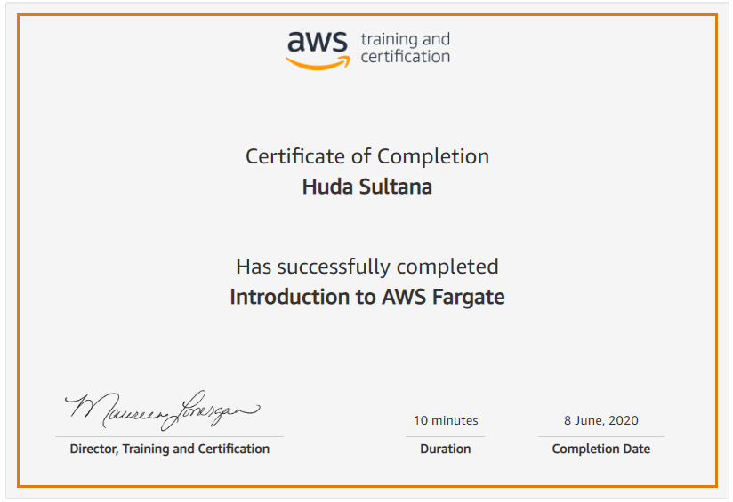

Coding Challenges Details: (Attach the snapshot and briefly write the report for the same)

**PROGRAM 1 .**

**#find factors of a number**

**def print_factors(num):**

**print("The factors of",num,"are:")**

**for i in range(1,num+1):**

**if num%i == 0:**

**print(i)**

**num=input(int("Enter a number greater than 0"))**

**print_factors(num)**